TABLE DROP-OUT AND MISSING DATA

How the baseline table was created
- Identify completers and non-completers:
  - The IDs of participants who did not complete the intervention were identified (18 participants).
  - All other participants were classified as completers (52 participants).
  - A new variable dropout_status was created in the dataset to label participants as either Completer or Non-completer.
- Select variables for comparison:
  - Baseline characteristics included age group (aldersgruppe_WHO), sex (kjønn), cancer type (Kreftform_forenklet_utkast), and BMI (BMI).
  - Age group, sex, and cancer type were treated as categorical variables, while BMI was treated as continuous.
- Prepare the data:
  - Ensure that participant IDs are in character format so that they can be correctly matched to the non-completers list.
  - Factor variables were explicitly defined so that the table function treats them as categorical.
- Create the table using CreateTableOne() (R tableone package):
  - The function compares baseline characteristics between completers and non-completers.
  - For categorical variables, the table shows counts and percentages of participants in each group.
  - For continuous variables, the table shows mean and standard deviation for each group.
- Improve readability:
  - All levels of categorical variables were displayed (showAllLevels = TRUE).
  - Quotes and extra spaces were removed for a cleaner presentation.
  - Continuous variables (e.g., BMI) were rounded to 1 decimal place for clarity.
  - The table was converted to a data frame to allow further formatting or export to Word/Excel.

Result:
The final table provides a clear comparison of baseline characteristics for completers vs. non-completers, allowing you to check for any systematic differences that could indicate attrition bias.
TABLE COMPARISON STEP-TEST; COMPLETERS AND NON-COMPLETERS
Group comparisons between completers and non-completers were conducted using the non-parametric Mann–Whitney U test (Wilcoxon rank-sum test). This test was chosen because the distribution of the 6-minute step test scores deviated from normality and because the non-completer group was relatively small, which reduces the robustness of parametric assumptions. In small and moderately sized samples, normality tests such as the Shapiro–Wilk test have limited power, and functional fitness measures in clinical populations often exhibit skewed distributions and outliers. The Wilcoxon test does not assume normality and is therefore considered a more conservative and appropriate method for comparing groups under these conditions.
FATIGUE SCORING SYSTEM
The Chalder Fatigue Questionnaire (CFQ) was scored using the Likert 0–3 method, in which each of the 13 items is rated from 0 (“less than usual”) to 3 (“much more than usual”), yielding a total fatigue score that reflects the severity of symptoms. This approach was chosen because it provides a continuous measure of fatigue, allowing for the detection of subtle differences between participants and over time, which is particularly relevant in intervention studies. In contrast to the bimodal 0–1 scoring, which is typically used for categorizing participants as fatigued versus non-fatigued, the 0–3 Likert scoring captures gradations in both physical and mental fatigue, enabling a more nuanced analysis of changes in fatigue severity in response to the resistance training program. Using this method ensures that the results are sensitive to individual variability and can be analyzed statistically as a continuous outcome, facilitating comparisons between groups and assessment of intervention effects.

SECONDARY OUTCOME: FUNCTIONAL FITNESS
After doing ANOVA table with effect size (partial n), but before doing within group change and between-group difference in change scores
i got this for step 6: check assumptions > shapiro.test(residuals(anova_model$lm)) Shapiro-Wilk normality test data: residuals(anova_model$lm) W = 0.98265, p-value = 0.2239 So do I use parametric or non-parametric? > leveneTest(step_test ~ treatment, data = data) Levene's Test for Homogeneity of Variance (center = median) Df F value Pr(>F) group 1 0.074 0.7862 96
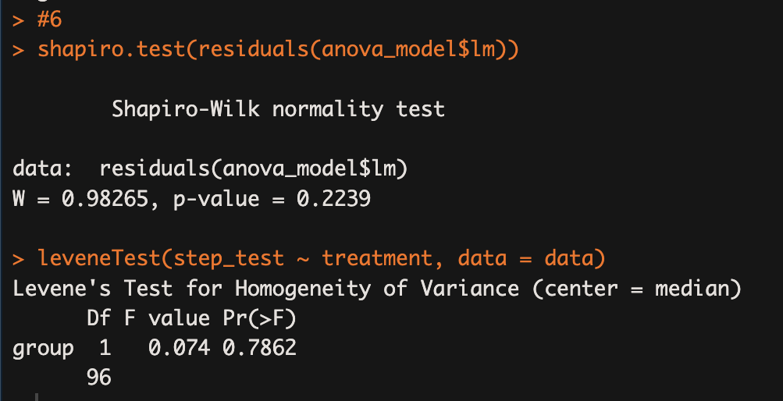
You should use the parametric tests. Your assumptions for ANOVA are satisfied.
Here is why:

1. Normality (Shapiro–Wilk test)
Result:
- W = 0.983
- p = 0.224
Interpretation:
- The null hypothesis of the Shapiro–Wilk test is that data are normally distributed.
- Because p > 0.05, you do not reject normality.
✔ Residuals are normally distributed.

2. Homogeneity of variance (Levene’s test)
Result:
- F = 0.074
- p = 0.786
Interpretation:
- The null hypothesis is equal variances between groups.
- Because p > 0.05, variances do not differ significantly.
✔ The homogeneity assumption is met.

3. Conclusion
Since both assumptions are satisfied:
✔ Mixed-design repeated measures ANOVA is appropriate
✔ Parametric follow-up tests should be used
So you should use:
- Paired t-tests for within-group pre–post changes
- Independent t-tests for between-group change scores
You do NOT need Wilcoxon or Mann–Whitney tests.

